Dragonwings Curricular Aids
“American Propaganda from the
Late 19th Century in Response
to Chinese Immigration”
Purpose:
The purpose of this lesson is to introduce students to propaganda related to Chinese immigration from the United States in the 1870’s through the 1890’s in order to gain some understanding of the climate in which the story takes place. Students will identify the sentiment being suggested by the propaganda piece/ political cartoon and will discuss the meaning and the purpose of these with their peers.

Background:
In 1882, Congress passed the “Chinese Exclusion Act,” the first significant legislation in the United States directed at controlling the population of a particular race or ethnic group. The act suspended immigration from China for ten years and made it impossible for Chinese already living in the United States to become citizens.

There was a huge influx of Chinese immigrants into the U.S. (primarily California) in the mid-19th century because of the Gold Rush of 1949 and the building of the Transcontinental Railroad. These immigrants often faced mistreatment and discrimination from American citizens. Several laws were passed in California targeting the Chinese, who were not allowed to vote, own property, attend school, or work in a government job. In one case (People vs. Hall), the conviction of a Caucasian man for murdering a Chinese immigrant was overturned because the only witnesses against him were Chinese, and “Chinese and other people not white” couldn’t testify in court against a white man. Tensions were made worse by the “long depression” of the 1870’s which made it difficult for many Americans to find work. In 1877, an anti-Chinese riot in San Francisco led to the deaths of four Chinese men and caused hundreds of thousands of dollars’ worth of damage.

Materials:
Print (and preferably laminate) copies of the propaganda pieces included in this unit. Have enough so that each student has his/her own copy. It’s okay if there are multiple copies of each piece.

Room Setup:
Have the room set up so that students will be able to sit or stand directly across from one another for discussion. Concentric circles with the inner circle facing out and the outer circle facing in work well for this. Students may also line up in two rows facing each other.

Procedure:
Hand out a copy of a propaganda piece to each of the students. Give them a few minutes to look over their cartoons and think about the discussion questions (Appendix A) about their particular piece. The instructor may choose one cartoon to not distribute to students and model the activity using that prior to starting the students on the task.
After they have had a chance to look at their own cartoon, set them up across from one another in chairs or in standing rows/circles. Each student is to trade their cartoon with that of the student across from him/her. Then, the pairs should take turns discussing with their partner what the particular cartoon says about the experience of Chinese immigrants in America and how Americans responded to them. Each student should point out one thing about their cartoon that they think demonstrates the attitude of the piece the best, the “statement piece” of the propaganda. Each student should also ask his/her partner at least one question about their partner’s piece. The idea is to get a dialogue going about each particular work.
After students have had an opportunity to discuss their pieces, have them trade back so that they have their original one. Each partner dialogue should take around two minutes. When the first round is done, have one of the groups of students move one person to the right or left, so they are seated with a new partner. Have one student circle around to the start if in lines. Follow the procedure for the first round again as often as time allows and the students are being productive. You may vary the procedure after a few rounds by having the students not trade after one round and let them keep the propaganda piece of their partner to lead discussion on that.
After students have had time for individual discussions, the instructor may ask students with identical works to get together to explain theirs to the class as a whole. If the instructor decides to do this, having a projection (overhead or slide show) of each piece available would be a good idea. Since propaganda pieces are intended to persuade people to take a certain point of view about a topic, this would be a good discussion topic. Also consider, what is the point of view of the cartoonist regarding Chinese immigrants/immigration, and what are they trying to persuade the reader about?

Follow Up Activities: (optional)
Research: Students may research one of the California laws targeted at the Chinese and write briefly about how that law may have been influenced by discrimination and what it says about Chinese people. Students may also research other immigration laws and compare them to the laws they’ve learned about.
Drawing: Students may attempt to draw their own political cartoon relating to what they’ve learned about. The drawing could be accompanied by a brief writing about the choices they made as an artist.
Reading: Students may read the portion of Chapter Four starting with the line that begins, “Father said it was time.” This can be found in the middle of page 66 in the Harper Trophy 25th Anniversary Edition. They should read through the next six chapters to get an idea of the tensions between the Americans and the Chinese.
For a more personal encounter, students may read in Chapter Seven starting with the line that begins with, “I had begun to think that demons were not really so bad.” The next eight paragraphs detail an encounter that Moon Shadow has with a gang of “demon” boys.

Appendix A
Discussion Questions

Spend a bit of time looking at the propaganda piece that you have been given. Ask yourself these questions to prepare you to discuss this with your peers.

- What point about Chinese immigration is this piece trying to make?

- What, in particular, makes you think that? Try to find the one portion of the piece that has the most impact for you.

- How are the Chinese people portrayed, especially in comparison to other racial/ethnic groups or other immigrants? Is there a particular aspect of a Chinese person -- a body part, for example -- that’s emphasized?

- Are the Chinese people seen as being a threat? How so? As victims? How?

- What particular traits about the Chinese are depicted in the piece, both positive and negative? What kind of stereotypes do you see, if any?

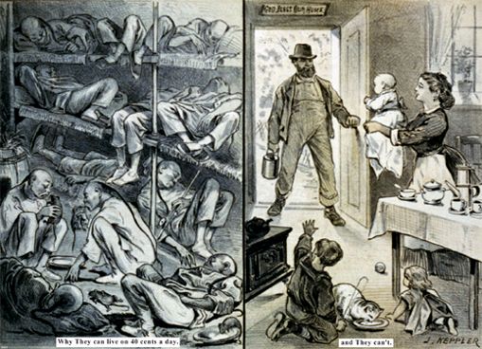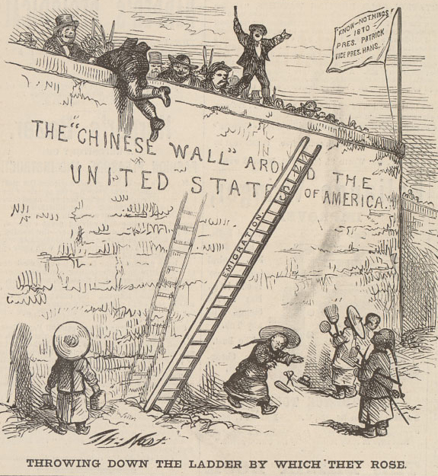
1
2
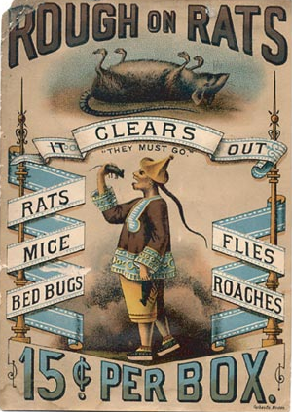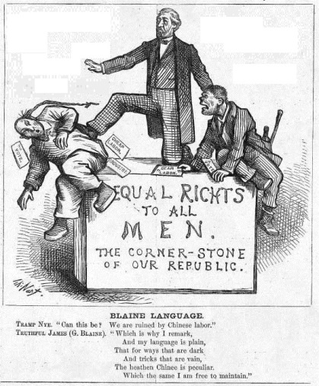
3
4
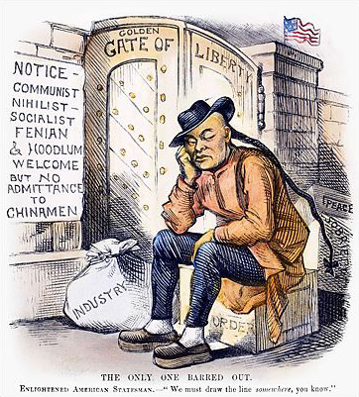
5

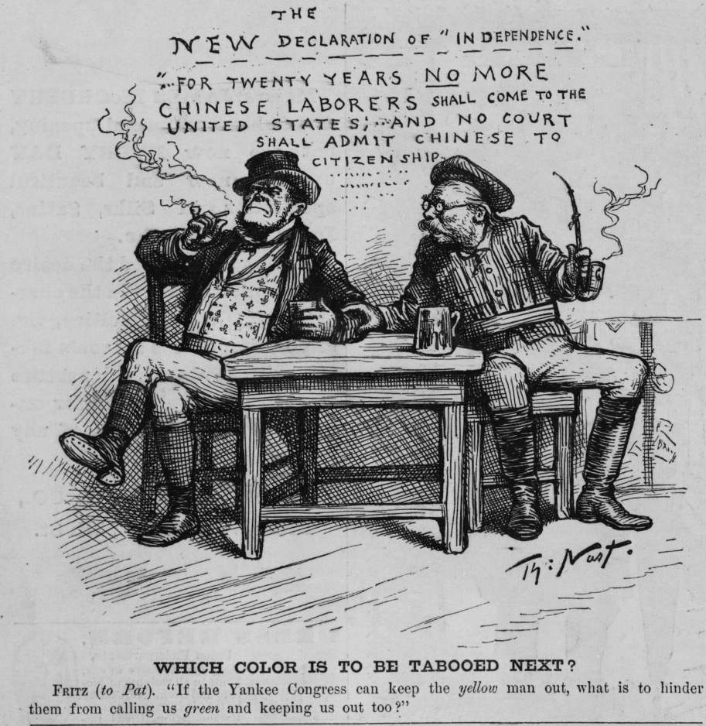
6
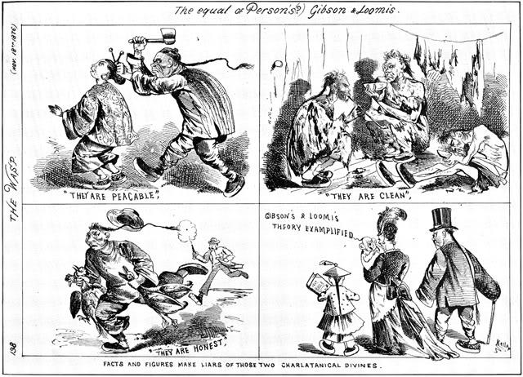
7
8

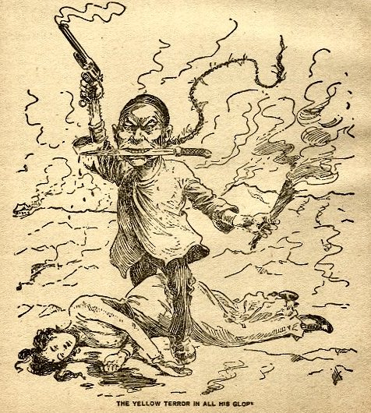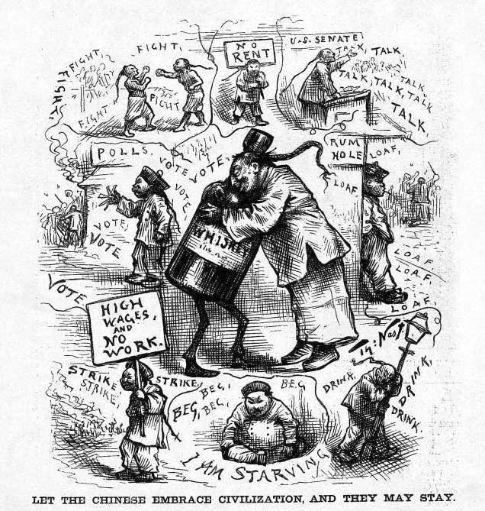
9
10
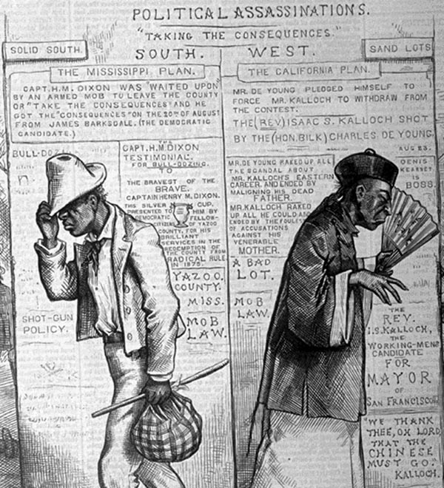
11

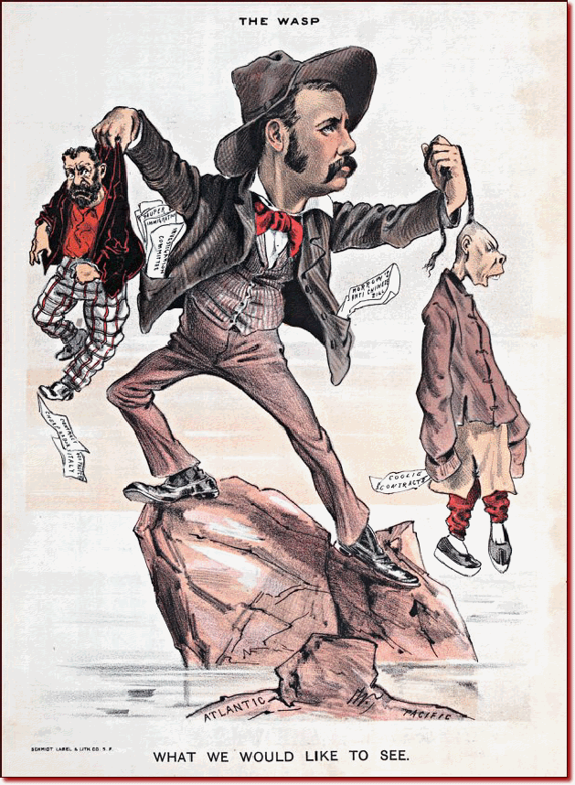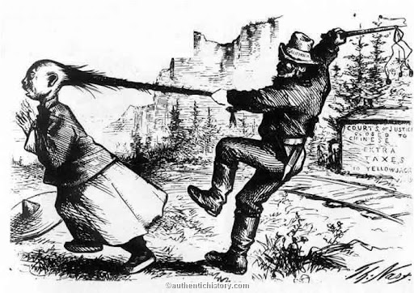
12
133
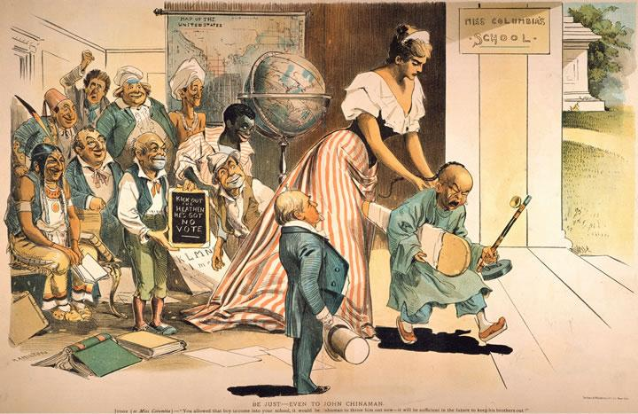Appendix B
143
Source Material
#1, #9 Sharp, Gwen. “Old ‘Yellow Peril’ Anti-Chinese Propaganda.” Sociological Images. The Society Pages. http://thesocietypages.org/socimages/2014/06/20/old-yellow-peril-anti-chinese-posters/
#2, #4, #6, #7, #10 Nast, Thomas. “Tag Archives: Irish and Chinese.” Thomas Nast Cartoons.com. http://thomasnastcartoons.com/tag/irish-and-chinese/
#5 “A Brief History of Tolerance in America.” Slide #6. Time on-line. http://content.time.com/time/photogallery/0,29307,2011978_2179337,00.html
#3 C.N. “Racist Caricatures Through the Years.” The Color Line. The Society Pages. http://thesocietypages.org/colorline/2009/07/29/racist-caricatures-through-the-years/
#8 “Two Pictures Telling the Same Story.” Modern American History. 21 February 2011. http://blogs.baruch.cuny.edu/his1005spring2011/category/admin-only-featured/
#11 Nast, Thomas. “19th Century: 1870’s.” Dartmouth College. http://www.dartmouth.edu/~hist32/History/19th%20Century.htm
#12 Grace, Roger. “Young Solon Champions California’s Stance in Favor of Chinese Exclusion.” Metropolitan News-Enterprise. 16 Oct. 2006. Metnews.com. http://www.metnews.com/articles/2006/perspectives101606.htm
#13 “The Rutherford B. Hayes Administration (Republican 1877-1881).” Authentic History.com. http://www.authentichistory.com/1865-1897/3-gilded/1-hayes/index.html
#14 “Be Just - Even to John Chinaman," 1893.” The History Project. University of California, Davis http://historyproject.ucdavis.edu/ic/image_details.php?id=4883

Appendix C
Notes on Graphics
#1 –
#2 –
#3 –
#4 –
#5 –
#6 –
#7 –
#8 –
#9 –
#10 –
#11 –
#12 –
#13 –
#14 –

