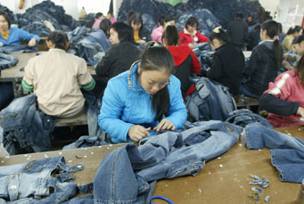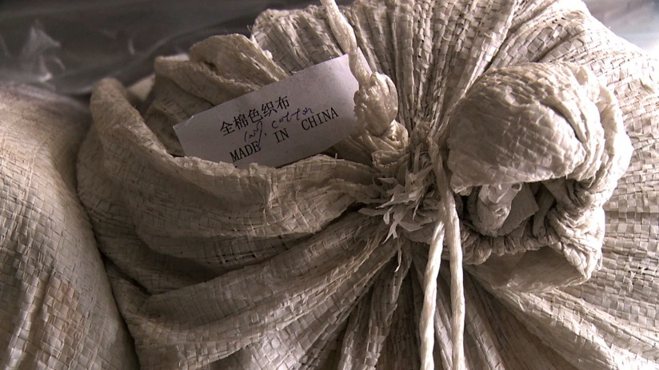

**OUR FEATURED**

**PRESENTATIONS**

*Cotton Road*  
www.cottonroadmovie.com  
Not yet available on DVD

*China Blue*  
http://www.pbs.org/independentlens/chinablue/Teddy Bear Films  
http://teddybearfilms.com/dvds

*Bitter Seeds*  
http://teddybearfilms.com

/2011/10/01/bitter-seeds-2/

Bullfrog Films  
http://www.bullfrogfilms.com/catalog/bitter.html